Methods

Corpus development

The aim of this research is to examine the temporal trends in the use of “Caucasian”, “White” and “European ancestry” in academic journals publishing on the topic of human genetics, with a particular interest in genetic counselling. To examine the temporal trends in the use of the word….. in human genetics research, a corpus, which is a XXdefineXX was created. To do this, a list of peer-reviewed academic journals, publishing research on human genetics was compiled. This list was formulated by using advanced search tools in the National Library of Medicine journal catalogue (National Library of Medicine, n.d) as well as the Google Scholar search engine using the search terms “genetics”, “genomics”, and “human genetics” Journal publication information was collected, including: journal name, abbreviation, scope, year established, publication frequency, peer review model, affiliations, publisher and access format (Supplementary Information/Appendix Table 1). Of these journals, nine were selected by the research team for the final corpus (Table 1). These journals were selected based on their relevance to the research question as well as their prominence in the field of human genetics and genetic counselling research. Factors considered for journal inclusion were …..[years of publication, impact factor, reputation, influence etc] The selection criteria focused on journals that publish research directly related to genetic counselling and human genetics whilst also considering impact factor and influence among the genetics community (Korf, 2024; McNeill, 2021).

PAGE BREAK AND INSERT TABLE 1 – landscape orientation of the page for the table – then page break and next section of your methods portrait orientation
Data Extraction

This study utilised two complimentary corpus-based approaches to extract word frequency data from the nine selected jounals in our corpus. The first method involved a full-text word frequency analysis on all articles published in the Journal of Genetic Counselling from its first publication in 1992, to October 2024. The second method extracted word frequency data from just titles and abstracts from the remaining eight journals in our corpus, spanning the date range of 1947 to December 2024. Together these methods allowed for a complimentary and in-depth analysis both within the Journal of Genetic Counseling and comparatively across the field of human genetics more broadly.

Full Text Analysis - Journal of Genetic Counselling

To undertake a full text analysis of the Journal of Genetic Counselling, a sub-corpus was created by aggregating PDF copies of all articles published in the journal (n = ??). Articles were accessed via Wiley Online Library through the University of Technology. Downloaded articles were kept as separate files organised by journal to allow word frequency analysis to occur at a text level rather than at a corpus level, as described by Goulart et al. (Goulart et al., 2024). Journal announcements, reviewers’ thanks and addendums were not included in the corpus. Given that this study’s primary focus is on published research articles, the exclusion of these additional entries avoided biasing our analysis at a per-article level (after Byoen et al 2021) . In contrast to Byoen et al.’s 2021 survey, which excluded book reviews, this study included them as any mention of the keywords within published literature is considered relevant to the scope of this research.

To extract word frequency data from the corpus, a Python script was developed to automate data extraction. The script was adapted from the chapter Programming for Corpus Linguistics in A Practical Handbook of Corpus Linguistics (Anthony, 2020) and designed to extract the word frequency of “Caucasian”, “White”, and “European ancestry” (Full Python script: Appendix A), counting once per article, as well as the publication year. In cases where an article mentioned the keywords numerous times, it was only counted once. To ensure the word count only included the keywords when referring to REA, a one-word context concordance list was created as defined by Tribble (2010). Python script was used to extract the word before and after each keyword. The context concordance list was manually reviewed by SW to remove instances of the keywords being used in contexts other than RAW, e.g. white as a colour or last name. Chat GPT was used as a debugging tool for the Python script utilised in this project (OpenAI, 2024).

Title and Abstract Analysis Across Eight Journals

To analyse the use of “Caucasian”, “White”, and “European ancestry” in article titles and abstracts across eight journals, an automated method was developed . titles and abstracts The corpus, which include n=titles and n=abstracts was then submitted/?uploaded to OpenAI’s GPT-4o model via its application programming interface (API) for analysis. In cases where abstracts were not available, only titles were included in the analysis. A summary of the number of titles and abstracts, and publication date ranges analysed per journal is provided in Table 2.

A standardised prompt was used to query ChatGPT to identify the use of “Caucasian”, “White”, and “European ancestry” in the titles and/ or abstracts of the articles uploaded:
Does this article use any terms like “Caucasian” or “white” or “European ancestry” in a way that refers to race, ancestry, ethnicity or population?
TITLE: {title}
ABSTRACT: {abstract}

This question was phrased in a neutral manor to avoid biasing the language model’s analysis. The prompt was crafted to search for terms related to European ancestry without suggesting preference for any terminology. A function-calling API was used to ensure standardised output from Open-AI for every article analysed. Detection parameters were designed to identify references to the term “Caucasian”, racial descriptors involving “White”, the phrase “European Ancestry” and other expressions describing populations of European origin. The system captured the exact terminology used, enabling a detailed analysis of language variations across the literature. The results were reviewed for accuracy and no examples were found of gpt-4o incorrectly extracting word frequency data.

PAGE BREAK AND INSERT TABLE 2 – landscape orientation of the page for the table – then page break and next section of your methods portrait orientation

Word frequency analysis

The data extracted using both methods yielded raw counts of the words “Caucasian”, “white” or “European ancestry” presence or absence in each article. This count data was standardised to reflect the percentage of articles containing each keyword out of the total number of articles published per year for each journal. Standardising the results allowed comparison across journals with varying publication frequencies and durations. This approach enabled the analysis of word frequency trends over time and across all journals included in this study. [Add in calculation of “moving average” to reduce “noise” in graphs]

Table 1: Demographic Characteristics of the eight journals included in this study

Journal | Launch Date | Impact Factor | Frequency/year | Peer Review Model | Affiliations | Publisher | Access
American Journal of Human Genetics | 1949 | 8.1 | Monthly | Single Blind Peer Review | American Society of Human Genetics (ASHG) | Cell Press | Hybrid Open Access
European Journal of Human Genetics | 1994 | 3.7 | Monthly | Double Blind Peer  Review | European Society of Human Genetics | Nature Portfolio | Hybrid Open Access
Familial Cancer | 2000 | 1.8 | Quarterly | Single Blind Peer Review | N/A | Springer | Hybrid Open Access
Genetic Epidemiology | 1984 | 1.7 | Monthly | Single Blind Peer Review | International Genetic Epidemiology Society | Wiley | Hybrid Open Access
Heredity | 1947 | 3.1 | Monthly | Double Blind Peer Review | The Genetics Society | Nature Portfolio | Transformative Journal
Human Genetics | 1964 | 3.8 | Biweekly | Single Blind Peer Review | N/A | Springer | Hybrid Open Access
Human Genomics | 2009 | 3.8 | Quarterly | Double Blind Peer Review | N/A | Springer | Open Access
Journal of Community Genetics | 2010 | 1.5 | Bimonthly | Double Blind Peer Review | International Society of Community Genetics and Genomics | Springer | Hybrid Open Access
Journal of Genetic Counselling | 1992 | 1.9 | Bimonthly | Double Blind Peer Review | National Society of Genetic Counsellors (US) | Human Sciences Press | Hybrid Open Access

Note: This table includes the demographic characteristics of all journals in this study, including, name, journal launch date, publication frequency, peer review model, affiliations, publisher and access model.

Table 2:
Number of Articles Analysed per Journal and Availability of Abstracts

Journal Name | Publication Range | Number of articles analysed | Number of abstracts analysed | Full text analysis
European Journal of Human Genetics | 1993-2024 | 6227 | 388 | NA
American Journal of Human Genetics | 1997-2024 | 8085 | 0 | NA
Familial Cancer | 1985-2024 | 1510 | 71 | NA
Genetic Epidemiology | 1984-2024 | 3436 | 2222 | NA
Heredity | 1947-2024 | 9455 | 156 | NA
Human Genetics | 1964-2024 | 12213 | 197 | NA
Human Genomics | 2003-2024 | 908 | 385 | NA
Journal Of Community Genetics | 2010-2024 | 693 | 61 | NA
Journal of Genetic Counseling¹ | 1992-2024 | 2477 | 2477 | 2477
¹Full Text analysis was conducted on this journal.

Note. This table shows the number of articles and abstracts analysed across nine journals for this research. All articles had their titles analysed; abstracts were included only where available.

Results

A total of 45,004 articles published between 1947 and 2024 across nine peer-reviewed academic journals on the topic of human genetics were included in this study. Of these, full text analysis was performed on 2477 articles, XX abstracts and XX titles. Abtracts were not available for XX number of articles.

Word Frequency analysis – full text analysis Journal of Genetic Counselling

Of the 2477 full text articles from the Journal of Genetic Counselling, [then provide overall break down of the word usage for the three words]. [In the Journal’s first year of publication (1992), t “Caucasian”
appeared in 3.57% of articles. Usage increased over the next fifteen years, peaking in 2007 at 7.5%. Afterward, it steadily declined, appearing in 0.68% of articles in 2023, representing a relative decrease of 90.9%. No mentions of “Caucasian” were found in the articles analysed from 2024 (Figure 1).
By contrast, the use of “white” in the journal increased from 1.27% in 2003 to a peak of 14.84% in 2020. This represents a relative increase of approximately 1068.5% over seventeen years. Usage then declined slightly to 13.16% in 2023 and 10.53% in 2024 (Figure 2).
Lastly, the term “European ancestry” appeared in 3.13% of articles published in 1994. Between 1995 and 2017, there were no recorded mentions of the term. It reappeared in 2018, featuring in 0.96% of articles, and increased slightly to 1.29% in 2020. By 2023, mentions had decreased to 0.68% of published articles (Figure 3).

Page break THEN HAVE FIG 1 – 3 then page break for next section of your results

Word Frequency analysis – title and abstract

Present this section as above… Of the XX titles and abstracts across eight journals, [then provide overall break down of the word usage for the three words].

The use of “Caucasian” in titles and abstracts followed a steady upward trend, peaking in 2001 at 1.4%. By 2023, this had declined to 0.12%, a relative decrease of approximately 91.4% and by 2024, the term was not used in any of the articles analysed (Figure 4). By contrast,

the use of “white” to describe REA was not detected in any titles or abstracts prior to 1977. In 1977, mentions of “white” accounted for only 0.29% of the articles analysed that year. Usage increased between 1985 and 1989, reaching 0.58%, before declining over the following decade. It then rose again, peaking in 2021, when “white” was mentioned in 0.63% of titles and abstracts (Figure 5).

The first mention of “European ancestry” in the title and abstract analysis appears in 1988, accounting for 0.2% of articles that year. Usage of the term remained below 0.2% until 2013, when an upward trend began. Between 2013 and 2023, the use of “European ancestry” shows a 127.8% relative increase, rising from 0.36% to 0.82% (Figure 6).

Page break THEN HAVE FIG 4 – 6 then page break for next section of your results
Comparative analysis
- Describe the concordance between both methods and present your graph where you overlay JGC with the other 8 for each word individually – to highlight that the trend is consistent between methods.

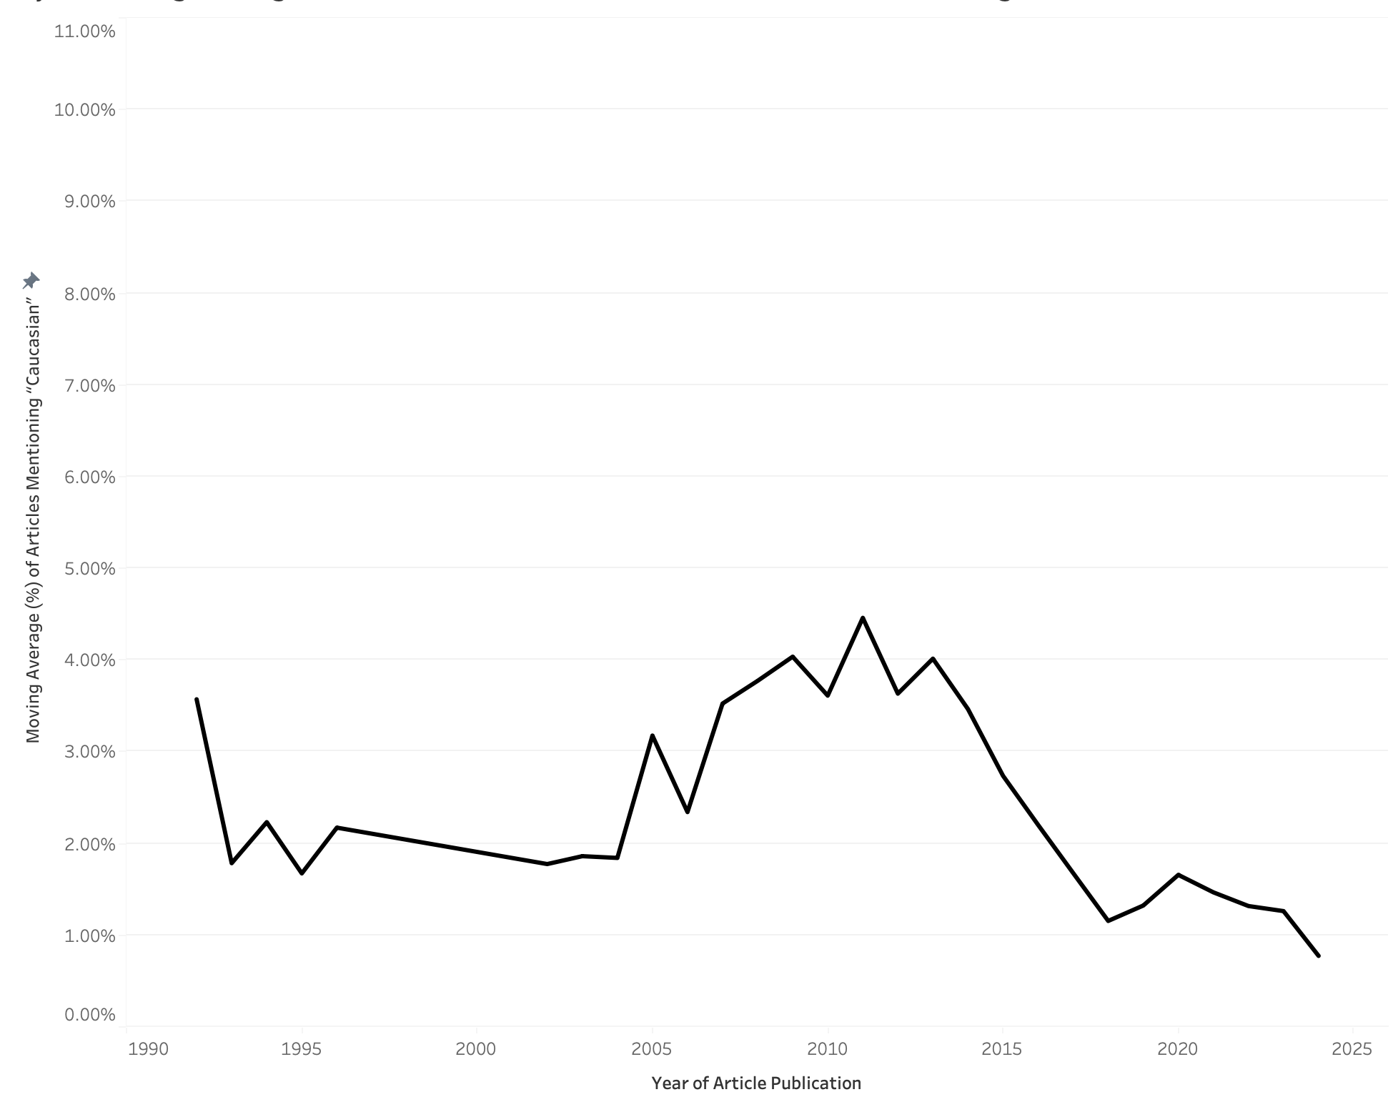
Figure 1: Frequncey of the usage of the word “Caucasian” in the Journal of Genetic Counselling calculated as the number of mentions per article per year. Frequency is presented here as five-year moving average.

Figure 2
Five Year Moving Average of the use of “White” in the Journal of Genetic Counselling
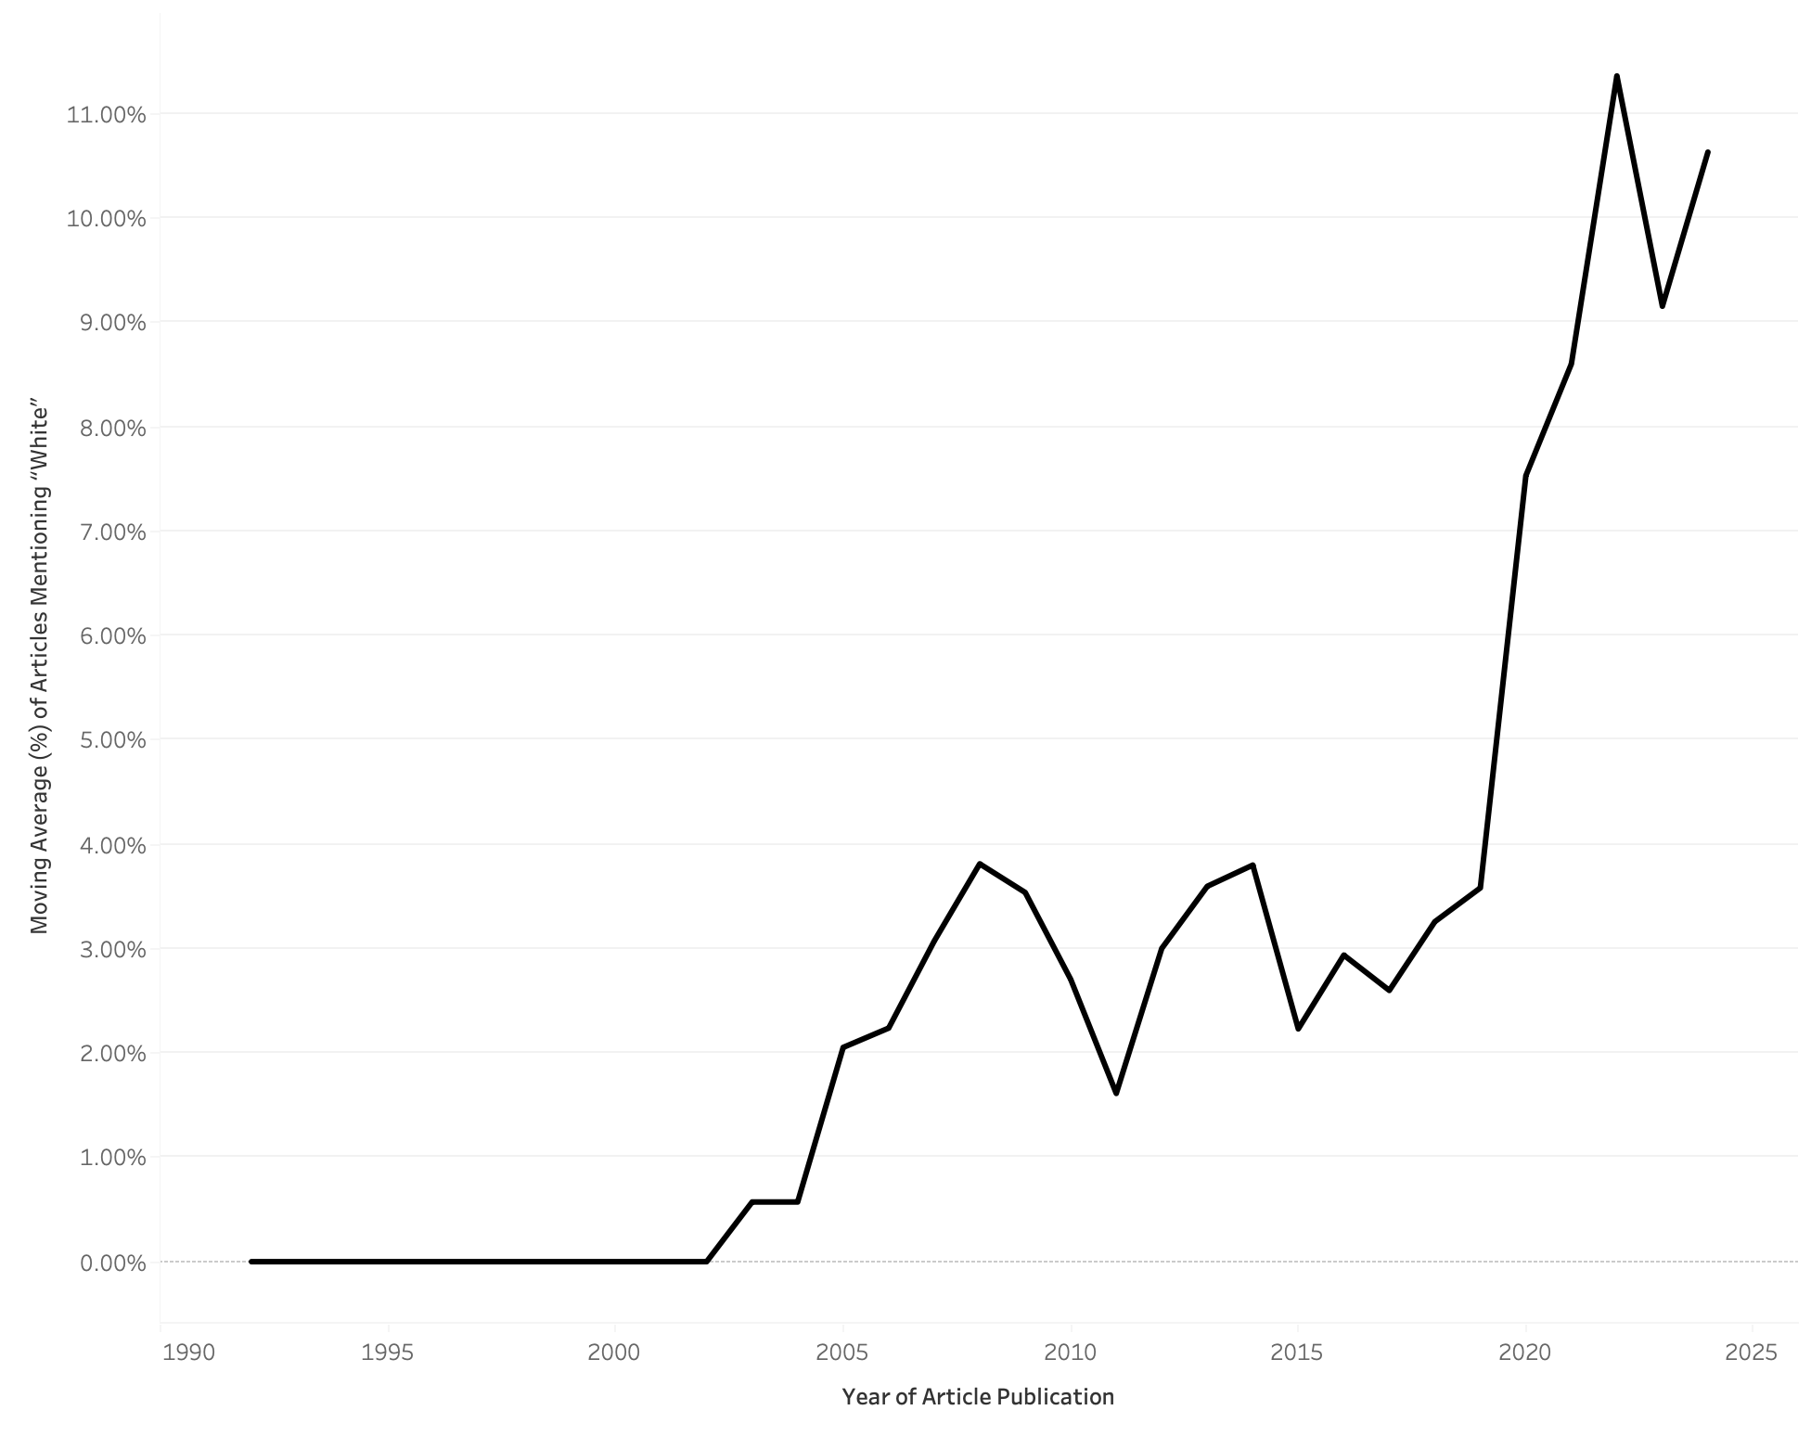
Note: This figure displays a five-year moving average of the frequency of the term “White” in the Journal of Genetic Counseling, calculated as the number of mentions per article per year.
Figure 3
Five Year Moving Average of the use of “European Ancestry” in the Journal of Genetic Counselling
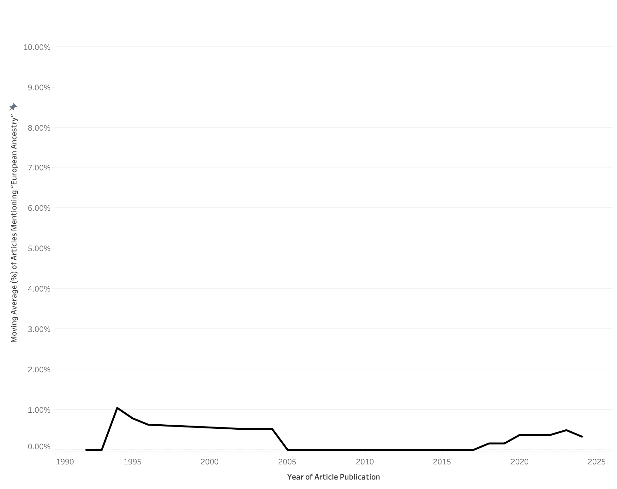
Note: This figure displays a five-year moving average of the frequency of the term “European Ancestry” in the Journal of Genetic Counseling, calculated as the number of mentions per article per year.

Figure 4
Five Year Moving Average of the use of “Caucasian” in the Titles and Abstracts across Eight Journals Publishing on the topic of Human Genetics.
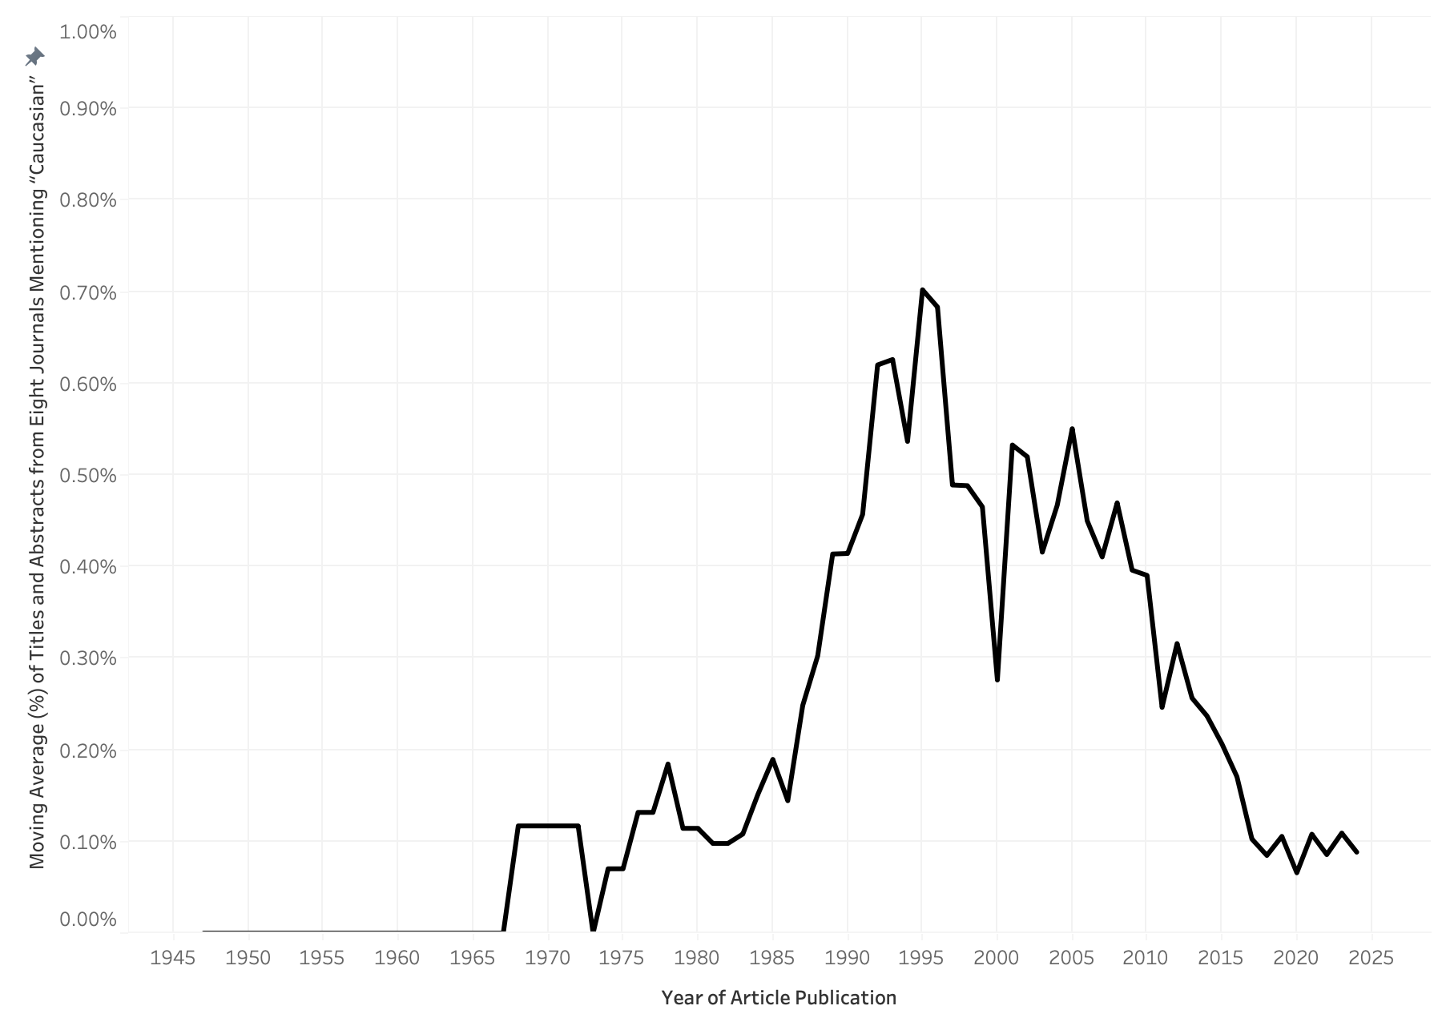
Note: This figure displays a five-year moving average of the frequency of the term “Caucasian” in titles and abstracts of eight journals publishing on the topic of human genetics, calculated as the number of mentions per article per year.

Figure 5
Five Year Moving Average of the use of “White” in the Titles and Abstracts across Eight Journals Publishing on the topic of Human Genetics.
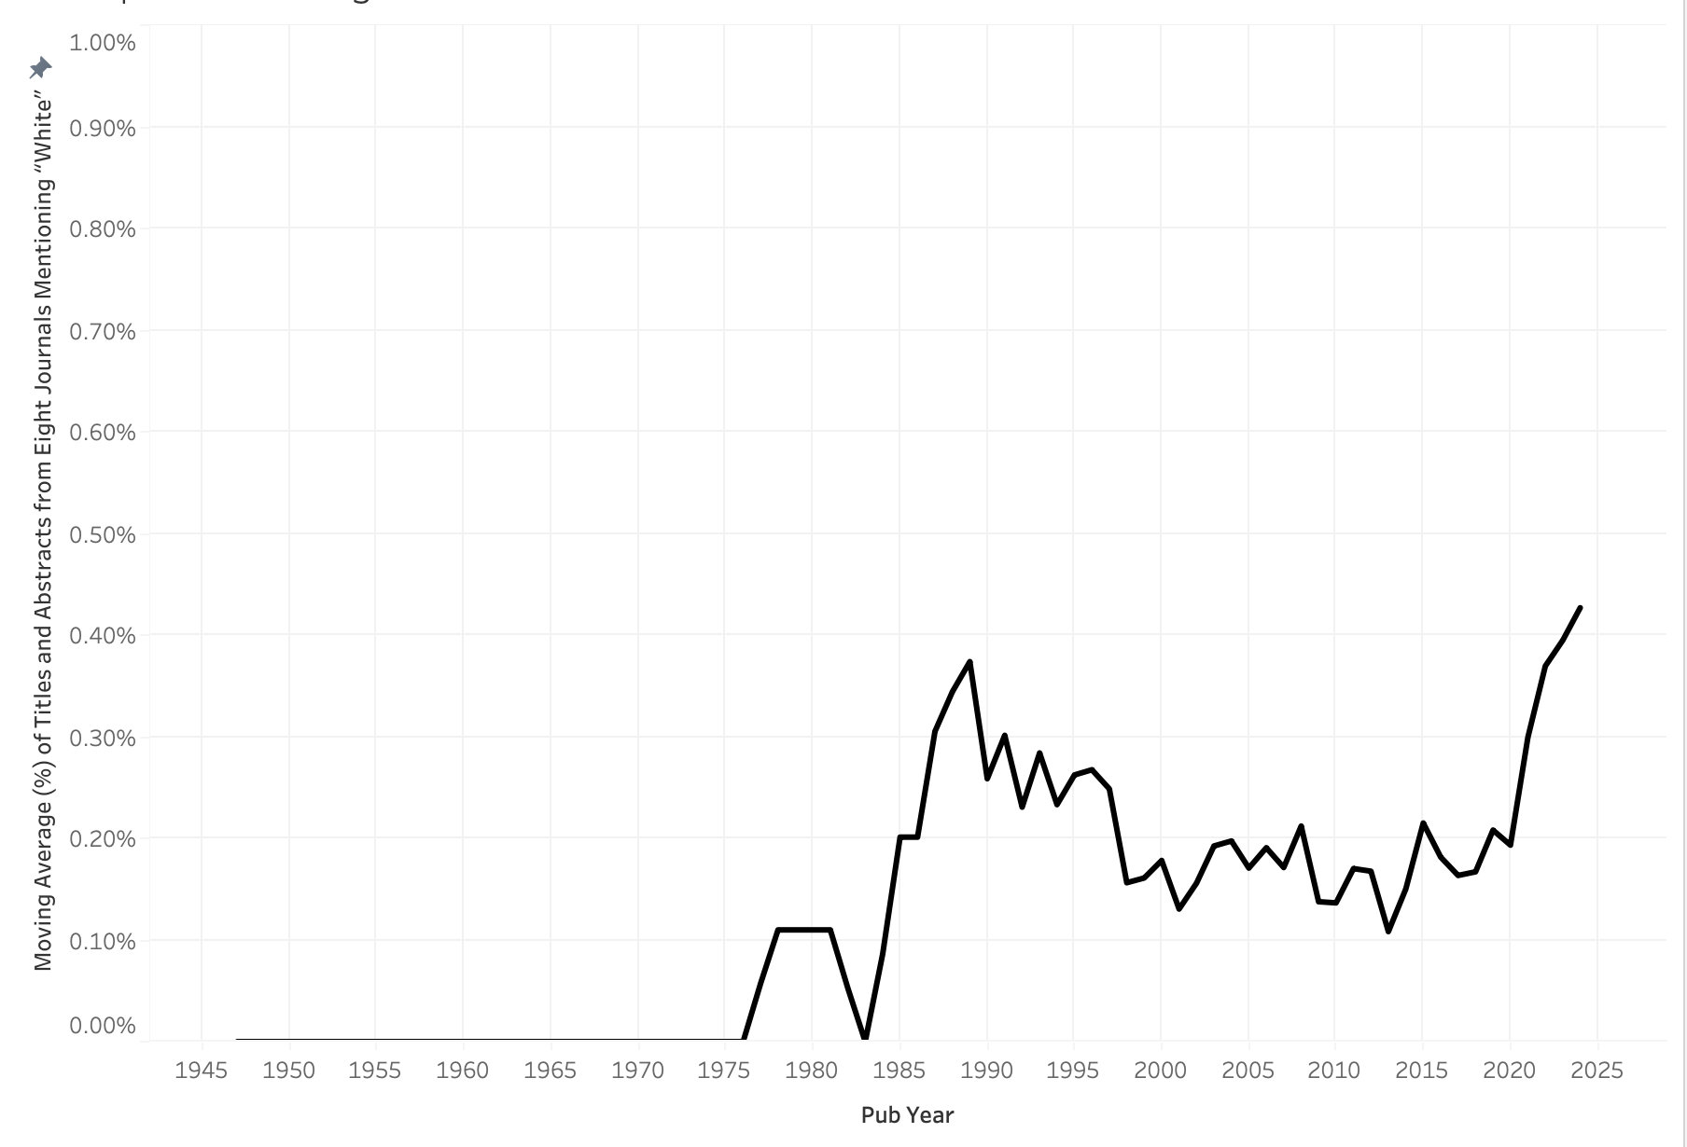
Note: This figure displays a five-year moving average of the frequency of the term “White” in titles and abstracts of eight journals publishing on the topic of human genetics, calculated as the number of mentions per article per year.
Figure 6
Five Year Moving Average of the use of “European Ancestry” in the Titles and Abstracts across Eight Journals Publishing on the topic of Human Genetics.
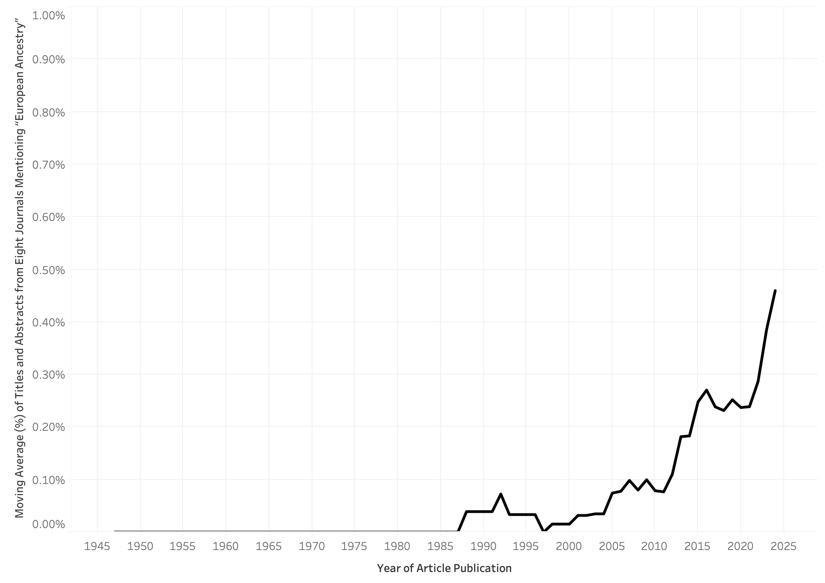
Note: This figure displays a five-year moving average of the frequency of the term “European Ancestry” in titles and abstracts of eight journals publishing on the topic of human genetics, calculated as the number of mentions per article per year.

Figure 7
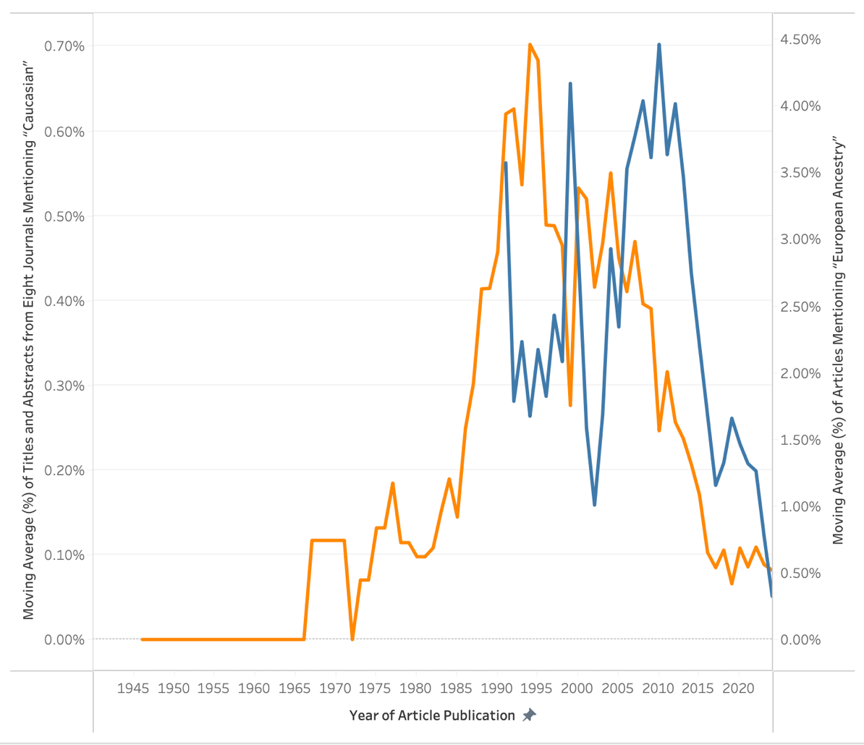
Twin Axis of Five-Year Moving Average of the use of “Caucasian” in the Journal of Genetic Counselling and Titles and Abstracts across Eight Journals Publishing on the topic of Human Genetics.

“Caucasian” in Abstracts and Titles Across Eight Journals
“Caucasian” in the Journal of Genetic Counselling

Note: This figure shows the five-year moving average word frequency trends from the title/abstract data from eight journals (left axis) and the full-text analysis of the Journal of Genetic Counseling (right axis).

References

Anthony, L. (2020). Programming for Corpus Linguistics. In M. Paquot & S. T. Gries (Eds.), A Practical Handbook of Corpus Linguistics (pp. 181-207). Springer International Publishing. https://doi.org/10.1007/978-3-030-46216-1_9
Byeon, Y. J. J., Islamaj, R., Yeganova, L., Wilbur, W. J., Lu, Z., Brody, L. C., & Bonham, V. L. (2021). Evolving use of ancestry, ethnicity, and race in genetics research-A survey spanning seven decades. Am J Hum Genet, 108(12), 2215-2223. https://doi.org/10.1016/j.ajhg.2021.10.008
Crossref. (n.d.). Crossref metadata database https://www.crossref.org/
Goulart, L., Staples, S., Novikov, A., Picoral, A., & Reppen, R. (2024). An introduction to CIABATTA: Increasing accessibility to corpus creation for non-experts. Research Methods in Applied Linguistics, 3(3), 100146. https://doi.org/https://doi.org/10.1016/j.rmal.2024.100146
Korf, B. R. (2024). 75 years of The American Journal of Human Genetics. Am J Hum Genet, 111(1), 1-2. https://doi.org/10.1016/j.ajhg.2023.12.003
McNeill, A. (2021). A new impact factor for European Journal of Human Genetics. Eur J Hum Genet, 29(8), 1165. https://doi.org/10.1038/s41431-021-00941-7
National Library of Medicine. (n.d). National Library of Medicine Catalog https://www.ncbi.nlm.nih.gov/nlmcatalog
OpenAI. (2024). ChatGPT (October 2024 Version https://chat.openai.com
Tribble, C. (2010). The Routledge Handbook of Corpus Linguistics (1 ed.).

